EC-3711 SUMMER INTERNSHIP 

PYTHON FULL STACK WEB DEVELOPMENT
A INTERNSHIP REPORT

Submitted by
PRIYA DHARSHINI . S (950622106037)
in partial fulfilment for the award of the degree of

BACHELOR OF ENGINEERING
IN
ELECTRONICS AND COMMUNICATION ENGINEERING

EINSTEIN COLLEGE OF ENGINEERING, TIRUNELVELI

ANNA UNIVERSITY: CHENNAI 600 025

JULY - 2025

BONAFIDE CERTIFICATE
Certified that this internship report “WEB DEVELOPMENT” is the bonafide work of “PRIYA DHARSHINI .S (950622106037)” who carried out the internship work under my supervision.

SIGNATURE
Mrs. G. RENGANAYAGI M.E.,
HEAD OF THE DEPARTMENT
Electronics and Communication Engineering
Einstein College of Engineering
Tirunelveli-62701 SIGNATURE

SIGNATURE
Mrs. T. VIJI M.E.,
SUPERVISOR
Electronics and Communication Engineering
Einstein College of Engineering
Tirunelveli-62701 SIGNATURE

TABLE OF CONTENT

S.No | CONTENTS | PAGE NO
1 | Abstract | 4
2 | Project Overview | 4
3 | Module Description | 5
4 | Project Structure | 5
5 | Features | 5
6 | Software Requirements | 6
7 | Hardware Requirement | 6
8 | Technologies Used | 7
9 | HTML CODE | 7
10 | CSS Code | 11
11 | JavaScript Code | 14
12 | Outcomes | 15
13 | Offer Letter | 16
14 | Certification | 18
15 | Conclusion | 19
16 | References | 19

- ABSTRACT
The internship at Izeon Innovative pvt Ltd., Chennai aimed to provide practical experience in web development through the design and implementation of a Even Booking Web Application. To create a simple and responsive event booking platform where users can view upcoming events and book tickets by filling out a form. The goal is to demonstrate core front-end development skills.

The primary objective of the internship was to apply theoretical knowledge in a real-world project, understand the web development lifecycle, and gain hands-on experience with modern web technologies. The project was developed using HTML5, CSS3, JavaScript for responsive design. This Event Booking Platform displays a list of upcoming events with images, titles, and dates. Each event card has a "Book Now" button which opens a modal form. Users can enter their name and email to confirm their booking.

During the 1month internship, I was actively involved in requirement analysis, frontend design. This experience enhanced my technical knowledge, problem-solving abilities, and understanding of full-stack web development. Additionally, it improved my teamwork, communication, and documentation skills through collaboration with mentors and preparation of daily work reports.

In conclusion, the development of the Event Booking Web Application provided invaluable exposure to practical web development practices, bridging the gap between academic learning and real-world implementation. It strengthened my technical skills and prepared me for professional roles in the IT and web development industry.

- PROJECT OVERVIEW

The Event Booking Platform is a front-end web application developed using HTML, CSS, and JavaScript. The primary goal of the project is to provide users with a simple and interactive interface to browse events and book tickets online. The platform emphasizes ease of use, responsive design, and real-time feedback through JavaScript alerts after successful bookings.

• To design a user-friendly interface for event discovery and booking.
• To implement form validation and alerts for immediate user feedback.
• To create a responsive layout that adapts to different devices.
•To demonstrate the integration of HTML structure, CSS styling, and JavaScript interactivity in a real-world application.

- MODULE DESCRIPTION

Module | Purpose
Homepage | Introduces the platform and showcases events
Booking | Allows users to select events and confirm bookings
Alert | Gives alerts after booking an event

- PROJECT STRUCTURE

event-booking-platform/
│── index.html # Homepage
│── event.html # Event details page
│── booking.html # Booking form
│── confirmation.html # Confirmation page
│── CSS/
│ └── style.css # Styling
│── JS/
│ └── script.js # Interactivity & logic
│── images/ # Event images & icons

- FEATURES

- Homepage displaying upcoming events with images, descriptions, and dates.
- Event details page with information such as venue, time, and ticket price.
- Booking form where users enter their details and ticket preferences.
- JavaScript alert system that confirms booking instantly after submission.
- Responsive design using CSS Flexbox/Grid for mobile and desktop compatibility.
- Basic validation to ensure correct input (e.g., name, email, ticket count).

- SOFTWARE REQUIREMENT

The Event Booking Platform is developed using basic web technologies such as HTML, CSS and Javascript, and is implemented using the Visual Studio Code (VS Code) editor. The system requires a computer running on Windows 10 or higher, macOS or Linux operating systems with at least an Intel i3 processor,4GB of RAM, and sufficient storage space for development files. Visual Studio Code serves as the primary code editor, providing a user-friendly interface and extensions like Live Server, Prettier and Auto Rename tags to enhance coding efficiency and improve project management. The platform is designed to run on modern web browsers such as Google Chrome, Mozilla Firefox or Microsoft Edge which are required for testing and execution and execution of the websites. The HTML5 language is used for creating the structure of the web pages, CSS3 is used for styling and designing an attractive user interface and Javascript (ES6) is used for adding interactivity, form validation and dynamic content management. Optionally, libraries such as Font Awesome can be used to improve the responsiveness and visual appearance of the platform. The project follows a simple folder structure consisting of separate directories for HTML pages, CSS files, Javascript files and images to ensure modularity and maintainability. Overall, the software requirements are lightweight, ensuring that the application can be developed and executed efficiently on any standard computer system.

- HARDWARE REQUIREMENTS

• Processor: Intel Pentium IV or equivalent (1 GHz or higher)
• RAM: 2 GB
• Hard Disk: 2 GB free space (for project files, browser cache, and assets)
• Display: 1024 × 768 resolution monitor
• Input Devices: Standard keyboard and mouse
• Network: Basic internet connection (for testing and hosting)
systems like Windows, Android, iOS, or macOS, along with a reliable internet connection.

- TECHNOLOGIES USED

  - HTML5 & CSS3
HTML5 (Hyper Text Markup Language) is used to structure the web pages by defining various elements such as headings, paragraphs, images, forms, and buttons. CSS3 (Cascading Style Sheets) is utilized to enhance the visual presentation of the webpages, including layout design, colour schemes, fonts, and responsiveness. Together, HTML5 and CSS3 provide a clean, responsive, and accessible user interface for the online travel agency system.
  - JAVASCRIPT
JavaScript is implemented to add interactivity and dynamic behaviour to the website. It allows for real-time form validation, interactive navigation menus, data manipulation, and smooth user interaction. Through JavaScript, the system enhances user experience by enabling dynamic content updates without reloading the entire page.
  - VS CODE / IDE
Visual Studio Code (VS Code) is used as the primary Integrated Development Environment (IDE) for the development of the project. It provides features such as syntax highlighting, real-time error detection, code suggestions, and integrated version control. These features improve the efficiency of development and debugging processes.

- HTML CODE
<!DOCTYPE html>
<html lang="en">
<head>
<meta charset="UTF-8">
<meta name="viewport" content="width=device-width, initial-scale=1">
<title>Event Booking Platform</title>
<link rel="stylesheet" href="./project.css">
</head>
<body>
<header>
<h1>Upcoming Events</h1>
</header>
<div class="event-container">
<div class="event-card">
<img src="./images/music night.jpeg" alt="Event 1">
<h2>Music Night</h2>
<p>Step into an unforgettable evening where melodies come alive and rhythm fills the air! Join us for Musical Night, a celebration of music, passion, and pure entertainment. From soulful solos to electrifying band performances, this night promises to captivate your senses and stir your soul.</p>
<button onclick="openBookingForm('Music Night')">Book Now</button>
</div>
<div class="event-card">
<img src="./images/tech talk.jpeg" alt="Event 2">
<h2>Tech Talk</h2>
<p>Join us for an inspiring Tech Talk — a thought-provoking session designed to spark curiosity, foster innovation, and dive deep into the cutting-edge trends shaping our digital world. Whether you're a tech enthusiast, a professional, or simply curious about the future, this event promises insights that matter.</p>
<button onclick="openBookingForm('Tech Talk')">Book Now</button>
</div>
</div>
<div class="About">
<p>ABOUT</p>
<div class="p1">
<p>
🎉Get Ready for an Exciting Lineup of Upcoming Events! 🎉

We’re thrilled to announce two incredible events that promise to engage, entertain, and inspire! Whether you're a music lover or a tech enthusiast, there’s something special waiting for you.
</p>
<p>
🎶 Musical Night – A Symphony of Sounds
Immerse yourself in an evening of rhythm, melodies, and magical performances. Musical Night brings together talented artists, live music, and an atmosphere buzzing with energy. From soothing acoustic sets to high-energy acts, it’s a night you won’t forget.

🗓️ Date: [27.07.2025]
📍 Venue: [Tirunelveli]
</p>
<p>
💡 Tech Talk – Where Innovation Meets Insight
Join us for an enlightening Tech Talk that dives into the latest trends and breakthroughs in technology. Hear from industry experts, explore real-world applications, and gain fresh perspectives on the future of tech.

🗓️ Date: [27.07.2025]
📍 Venue: [Tirunelveli]
</p>
</div>
</div>

<!-- Booking Form (Modal) -->
<div class="modal" id="bookingModal">
<div class="modal-content">
<span class="close" onclick="closeBookingForm()">&times;</span>
<h2 id="eventTitle">Book Event</h2>
<form id="bookingForm">
<input type="text" id="name" placeholder="Your Name" required>
<input type="email" id="email" placeholder="Your Email" required>
<button type="submit">Confirm Booking</button>
</form>
</div>
</div>
<div class="footer">
<p class="final">THANK YOU</p>
<div class="Copy">
&copy; Copyrights for the event,events registeration are reserved.
</div>
</div>
<script src="./project.js"></script>

</body>
</html>

- CSS CODING

body {
font-family: Arial, sans-serif;
margin: 0;
background: #f0f0f0;
}

header {
background: #333;
color: white;
padding: 20px;
text-align: center;
}

.event-container {
display: flex;
justify-content: center;
gap: 20px;
padding: 40px;
flex-wrap: wrap;
}

.event-card {
background: white;
padding: 20px;
width: 250px;
box-shadow: 0 0 10px rgba(0,0,0,0.1);
text-align: center;
border-radius: 10px;
}
.event-card:hover{
background-color: black;
color:white;
}

.event-card img {
width: 100%;
border-radius: 10px;
}

.event-card button {
margin-top: 10px;
padding: 10px;
background: #007BFF;
color: white;
border: none;
border-radius: 5px;
cursor: pointer;
}

/* Modal styles */
.modal {
display: none;
position: fixed;
z-index: 2;
left: 0;
top: 0;
width: 100%;
height: 100%;
background: rgba(0,0,0,0.5);
}

.modal-content {
background: white;
margin: 10% auto;
padding: 20px;
width: 90%;
max-width: 400px;
border-radius: 10px;
text-align: center;
}

.modal-content input {
width: 90%;
padding: 10px;
margin: 10px 0;
}

.modal-content button {
background: green;
color: white;
padding: 10px;
border: none;
border-radius: 5px;
}

.close {
float: right;
font-size: 20px;
cursor: pointer;
}
.About{
text-align: center;
background-color: rgb(26, 14, 14);
color: aliceblue;

}

.About:hover{
background-color: white;
color: black;
}
p{
text-align: justify;
}
.Copy{
padding: 15px;
/* margin-left: 700px;
background-color: black; */
color: black;
text-align: right;
}
.final{
text-align: center;
font-weight: bolder;
font-size: larger;
}

- JS CODING

function openBookingForm(eventName) {
document.getElementById("bookingModal").style.display = "block";
document.getElementById("eventTitle").innerText = `Book: ${eventName}`;
}

function closeBookingForm() {
document.getElementById("bookingModal").style.display = "none";
}

document.getElementById("bookingForm").addEventListener("submit", function(e) {
e.preventDefault();

const name = document.getElementById("name").value;
const email = document.getElementById("email").value;
const event = document.getElementById("eventTitle").innerText;

alert(`✅ ${name}, your booking for "${event}" is confirmed!\nConfirmation sent to: ${email}`);
closeBookingForm();
});

- OUTCOMES

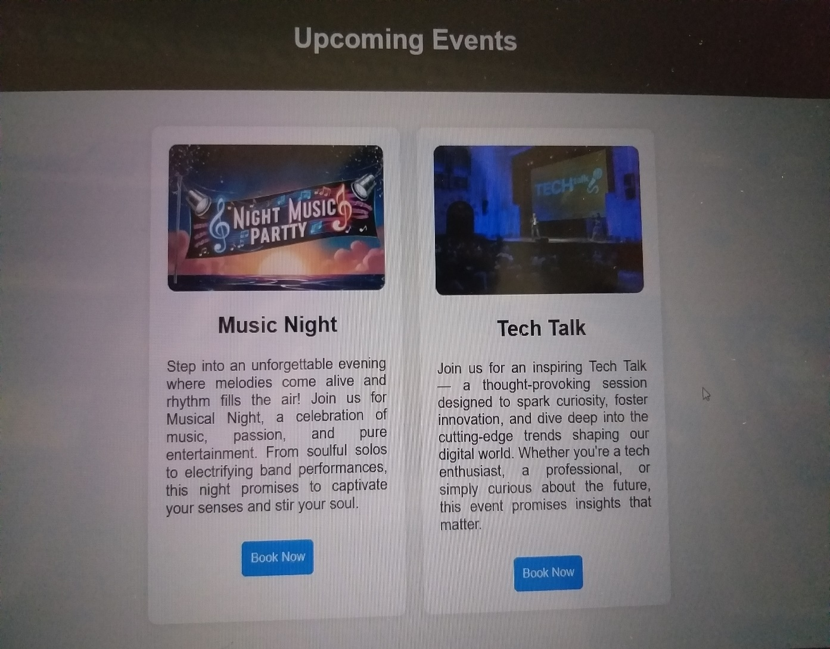
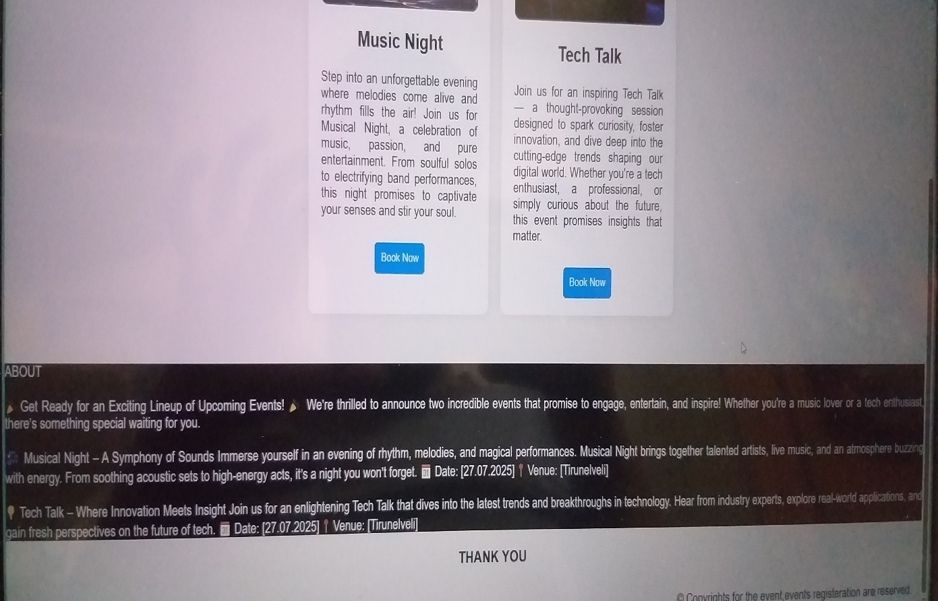

- OFFER LETTER

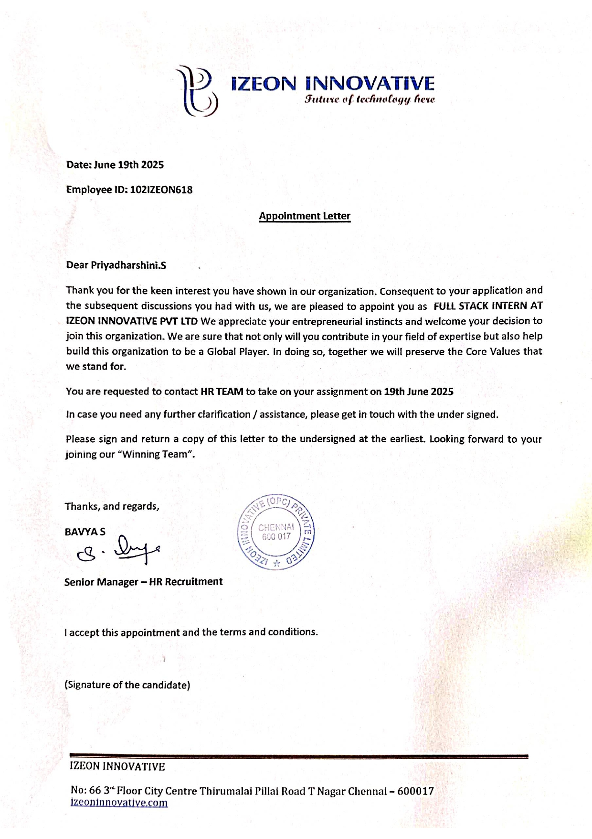

CONFIRMATION MAIL

Dear Priya Dharshini S
We want to welcome you to Izeon Innovative Pvt Ltd You are about to begin one of the most exciting times in your life, and everyone in our Team wants to help you make your "Izeon Experience" is a safe one. You are selected in interview process, you are appointed as are FULL STACK DEVELOPMENT INTERN AT IZEON INNOVATIVE PRIVATE LIMITED" Training will be start on JUNE 20th
You often hear that Izeon is a special place, and it is! Its depth of character, traditions, diversity, commitment to academic excellence, as well as its beautiful natural surroundings contribute to making Izeon such an exemplary academic environment in doing so, we encourage you to take appropriate personal and collective precautions when living, learning, and working at Izeon.
we look forward to your joining our organization on june 20th . please confirm your date of joining in return mail with your acceptance.
we are here to help you, at all times 24 hours a day, 7 days a week. you will see us around as you enjoy the campus.
NOTE: Updated Marksheets, Photo Copies, ID proof, Passport Size photos...

- CERTIFICATION
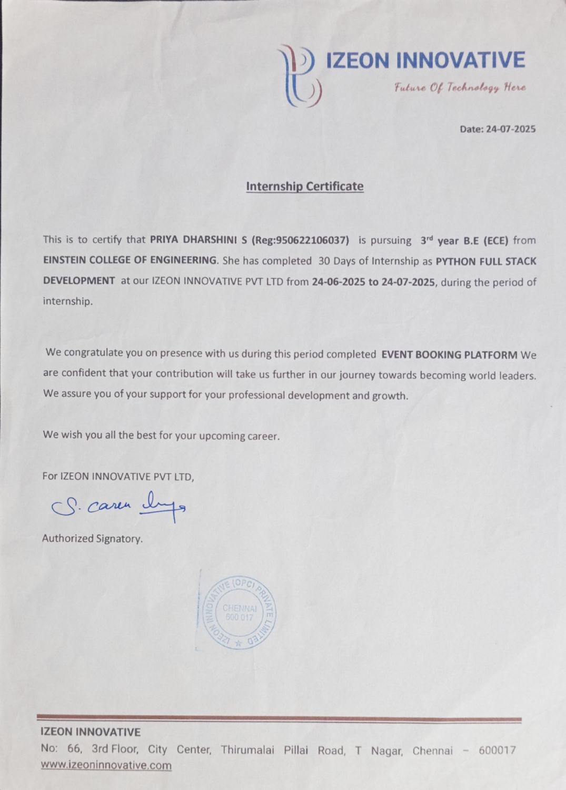

- CONCLUSION:
During my one-month internship at Izeon Innovative Private Limited, I had the opportunity to apply my knowledge of HTML, CSS, and JavaScript in developing a functional Event Booking Platform. This project allowed me to gain practical exposure to front-end web development, focusing on creating responsive layouts, designing user-friendly interfaces, and implementing interactive features such as booking alerts.
The internship experience not only enhanced my technical skills but also improved my ability to work within structured project timelines and follow professional development practices. By building this platform, I learned how to integrate design and functionality to deliver a smooth user experience, while also understanding the importance of validation, responsiveness, and real-time feedback in web applications.
In conclusion, the project reflects the knowledge and skills I acquired during the internship and demonstrates my ability to translate theoretical concepts into a working application. It serves as a strong foundation for future learning in advanced web technologies and provides valuable experience that will support my career growth in the field of web development.

16. REFERENCES
1.W3School.Web Development tutorials.
Available at:https://www.w3schools.com
2.MDN Web Docs.HTML,CSS,and JavaScript Documentation. Available
at:https://developer.mozilla.org

